Solar Farm To Produce Electricity for First United by Next Spring

The Environmental Justice Team has been partnering with the Interfaith Green Network to spread the word about an energy program called “community solar”. Following a Council decision on November 17, First United is signing on to three solar farms under development, thereby reducing the church’s carbon footprint and saving money at the same time.

Community Solar allows ComEd customers to “go solar” without actually installing panels on their property. You can subscribe to a portion of the electricity produced by a solar installation, and in return—whether you’re a church, a house, a condo, or an apartment—receive credits that reduce your electric bill.

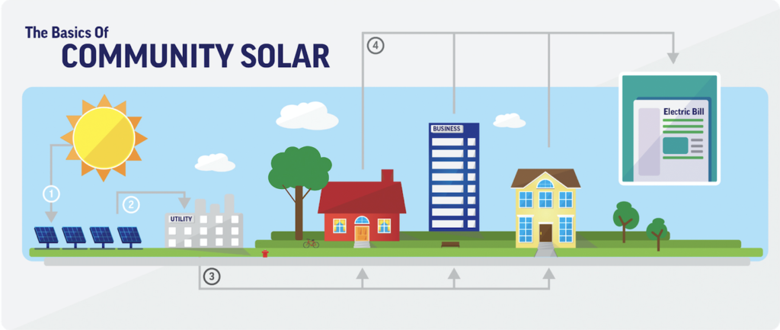

Here are some websites and links that might be helpful in getting information about community solar. After reviewing the various plans being offered, Interfaith Green Network is suggesting people consider two companies: Trajectory/Clearway and Nexamp. Both companies have similar offers for residential customers (houses, condos, apartments) while Nexamp seems to have a superior offer for larger electricity accounts (churches, businesses).

Citizens Utility Board (for basic information)
Trajectory website
Recorded Trajectory/Clearway video with PlanItGreen (local environmental collaborative)
Nexamp website
Registration site for recorded Nexamp video with Interfaith Green Network

For more information, contact these Environmental Justice Team members:
Jim Babcock, jlbabck@sbcglobal.net;
Art Spooner, sandaspooner@comcast.net

